**2015-16 St. Louis InnovateHER Business Challenge – Illinois Division**

Name of Nominee: Erica Harriss

Company Name: Saving Grace Beauty, LLC

Product name: Saving Grace Hair Powder

Company Address: 145 Somerset Drive

Glen Carbon, IL 62034 USA

Place of Incorporation: Illinois

Website: [www.savinggracehair.com](http://www.savinggracehair.com)

Phone Number: 618-580-3265

Email Address: [Erica@savinggracehair.com](mailto:Erica@savinggracehair.com)

Host Organization: Illinois Metro East Small Bus. Development Center at SIUE

Address: SIUE Alumni Hall, Room 2126 P.O. Box 1107

Edwardsville, IL 62026-1107

United States

Contact: Patrick McKeehan, Director

pmckeeh@siue.edu

618-650-2929

Two-sentence description: A custom hair care powder designed to cover growing roots, absorb oil, and overall extend the time between hair washes and coloring treatments. This product increases flexibility of time by reducing the time and expense of getting ready for the growing population of female professionals.

*Note:* There were a total of sixteen qualified applicants that participated in the St. Louis InnovateHER Business Challenge.

**Statement of Support**

Ms. Erica Harris, Founder and CEO or Saving Grace Beauty, is our nominee for SBA’s 2015-16 InnovateHER Business Challenge.

The center piece of Saving Grace Beauty is a product Erica created out of her only necessity – how can an active mother of three young children and wife to a full-time employed husband take care of all of her family responsibilities and at the same time allow her to color her own hair while be prepared leave the house on a moment’s notice?

Erica searched stores and the internet for a product that would color growing hair roots, absorb oil, and give her more time each day as well as between hair coloring treatments. Finding nothing that met her requirements, Erica formulated a hair powder that would more than meet her personal needs and give her confidence when she left the house.

Saving Grace Hair Powder was invented on Erica’s kitchen counter and become a part of her daily routine. When she started sharing her solution with other women, they completely understood the problem and immediately asked her to share samples of her product. Erica home-based product became a hit with moms gathered at the school bus stop, fellow tennis players at local park, and neighborhood friends. When Erica received a phone call from a popular hair salon asked wanting to carry her product, she realized it was time to make this a serious business venture.

Erica incorporated the business in November 2014, after a considerable amount of time refining her product using consumer feedback, researching competitors, designing and trademarking labels, buying raw materials and packaging, creating distribution channels, and writing a business plan. Saving Grace Beauty used $3000 in startup capital to quick go cashflow positive through on-line sales, wholesaling through hair salons, and direct consumer sales at the local farmers market. Saving Grace Beauty ended its first year in business with more than $90,000 in revenue, including a number of international sales.

I believe that Erica Harriss and Saving Grace Beauty more than exceeds the critieria for nominee to the InnovateHER Business Challenge. Erica’s hair powder product directly impacts the lives of women, especially improve their self-image in a highly competitive work environment. In addition, Erica has already proven her product is commercial viable, can successful compete in the marketplace and has international appeal.

I ask that you give Ms. Erica Harriss and Saving Grace Beauty fully consideration and your highly regard.

Thank you.



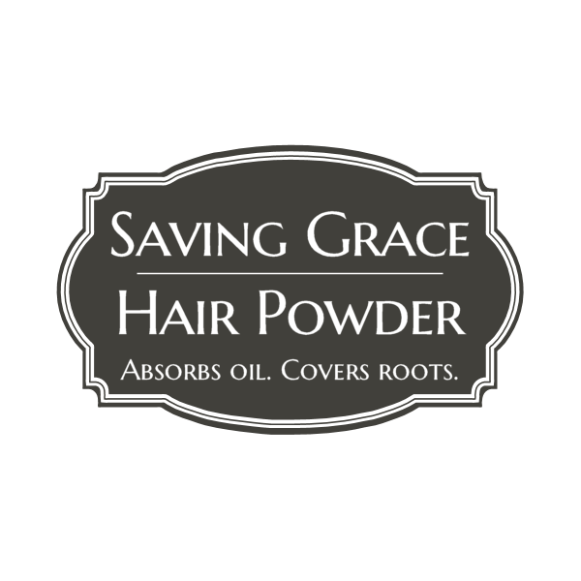

Saving Grace Beauty, LLC

InnovateHER Business Plan Competition

November 2015

www.savinggracehair.com

www.savinggracebeauty.us

www.savinggracebeauty.net

www.savinggracebeauty.co

145 Somerset Drive Glen Carbon, IL 62034

Erica Harriss

Founder

Saving Grace Beauty

erica@savinggracebeauty.com

618-580-3265

**Table of Contents**

**Contents**

Table of Contents 1

Executive Summary 2

Business Description - Getting to the Root of the Problem 3

Milestone Timeline 4

Growth Opportunity To Move Venture Forward 5

Market Analysis & Target Market 6

Target Market 6

Industry Analysis & Trends 7

Competitive Analysis & Strategic Position 7

Marketing Mix 12

Operations 13

Profit chart of powder: 13

Profit chart of brushes (add-on product): 13

Management and Organization 15

Consultants 15

Advisors 15

Financial Projections 16

Notes and Assumptions 19

Appendix 20

**Executive Summary**

Launched in November 2014, Saving Grace Beauty, LLC creates, manufactures and distributes Saving Grace Hair Powder - a revolutionary new product to solve common hair dilemmas affordably, easily and with instant results. Dream of snapping your fingers and being ready to take on the day? Saving Grace makes this aspiration more than a vision. Time is our most valuable resource, don’t waste it primping. Saving Grace will get you out of the bathroom and living your life. This game-changing new beauty product, which retails for $14.99, covers roots allowing users to go longer between salon color visits. Additionally, the product absorbs oil so users may shampoo less - saving both time and money. Saving Grace will literally be your saving grace. This new product was created following a basic 5-step formula for success: Build a prototype; get it in front of users or customers; let those users identify flaws and potential improvements; focus on growth; explain the problem the product is tackling with clarity and efficiency.

What is no one else doing in beauty that we ought to be doing? Saving Grace Beauty Hair Powder was created as a direct response to this question, effectively filling a void in the lucrative $40 billion dollar a year hair industry. Basic instinct keeps the beauty industry powerful. Our competitors are few, as we proudly were one of the first to market, particularly in the dry powder product form. We are able to match most natural hair colors, including red, largely due to our use of micas, while competitors, using only oxides, are required to make more color formulations to match the overall population. Sold primarily through online sales, our store is open 24 hours a day with quick shipping for those looking for an inexpensive instant hair fix. We are a debt free company which believes in small bootstrapped budgeting, and maintains full equity in the organization with no outside investors. Continuing to beat all odds, Saving Grace turned a profit within the first quarter of business. Our small size allows us to be very responsive to customers while helping to solve a huge problem, gaining a loyal and appreciative consumer following. The ability to learn faster, adapt more quickly, remain dynamic as new opportunities emerge and respond to consumers gives Saving Grace a sustainable competitive advantage.

Within the first 30 days of business, Saving Grace was astoundingly named by prestigious *Yahoo!Beauty* as a new “Artisanal Product To Keep On Your Radar,” shown on the Yahoo! homepage, featured in prominent *Gazelle St. Louis Magazine*, among other media outlets and named by popular beauty bloggers alongside mainstream beauty brand giants. Notably, this exceptional coverage was all achieved without using any funding or advertising dollars. Additionally, the vertical alignment in the media with nationally recognized names, which other brands have worked years to create, at such infancy stages of our company proves a very powerful future is in store for Saving Grace Beauty, LLC. Consumers are actively looking for a quick and affordable solution to hair dilemmas, and they can have both thanks to Saving Grace.

**Business Description - Getting to the Root of the Problem**

Saving Grace Hair Powder was created out of a need. For years, women have used a beauty hack of putting baby powder in hair to absorb oil. This worked on Erica Harriss, Saving Grace Beauty Founder’s light blonde hair. As her hair has turned naturally darker over the years, the trick began to give her hair a gray look as her roots grew out - certainly not what she was going for. Realizing she wasn’t the only one with this common dilemma, she set out to find a solution after being unable to find a product to meet her needs. Erica stalked beauty counters, consulted a chemist, ordered ingredients and began mixing in her kitchen. She passed out samples of the product to other women at the bus stop, at sports practices, and at church asking simply for an honest opinion and ideas for ways the product could be improved. The response of this initial test market of beta customers was overwhelming, with great feedback and constructive criticism which allowed the formulas and even packaging to be tweaked. In fact, Erica soon began getting messages from other women around the community asking if they could be a part of this group of testers, and a busy local salon called and asked if they could test and eventually sell the product in their store.

Contagious energy and excitement to get their hands on this product was the initial response to hearing about Saving Grace Hair Powder. Based on these findings, Erica decided to officially launch Saving Grace Beauty, LLC as a sole proprietorship in November 2014. June 23, 2015, the trademark “Saving Grace” was approved by the United States Patent and Trademark Office (USPO). Still in its infancy, the company is becoming known for selling hair powder and brushes. The brushes are an add-on, and not manufactured by Saving Grace Beauty. In the future, there are growth opportunities for the business to sell additional add-on or products under the brand name. The hair powder, which comes in 4 shades (blonde, light brown, dark brown and black) retails for $14.99 for a .37 ounce container at [www.savinggracehair.com](http://www.savinggracehair.com/).

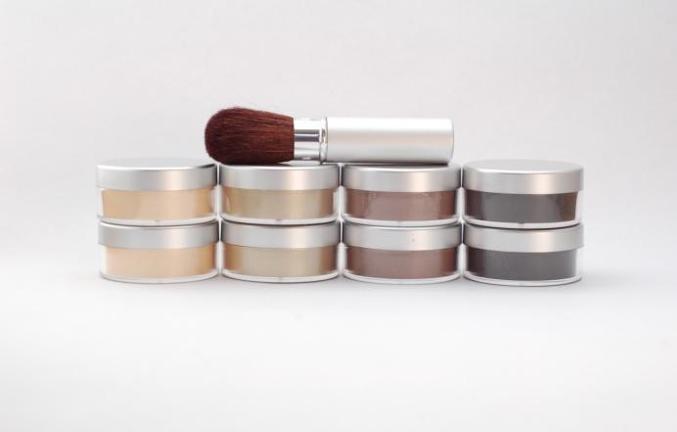

To provide a quick and affordable solution to common hair dilemmas while also making a profit is why we exist. Saving Grace Beauty feels passionately about giving women back two things which always seem in short supply -- time and money. Saving Grace Hair Powder saves time from daily shampooing by absorbing oils, and the colored powder helps mask those pesky roots in between salon visits. The product is an easy sell - *if* the consumer is educated on how the product can help them. Once we prove a demonstrable value proposition to the consumer, they eagerly purchase Saving Grace Hair Powder. Saving Grace is a unique brand for people like them.

## Milestone Timeline

|  |  |
| --- | --- |
| November 2014 | Formed LLC  Receive business license  Apply for Saving Grace trademark  [www.savinggracehair.com](http://www.savinggracehair.com/) goes live  Create Saving Grace Facebook page  Create Saving Grace Twitter  Treo Salon (Edw, IL) signs on as 1st retailer |
| December 2014 | Jane.com affiliate sale $1606.37 commission |
| January 2015 | Saponifier magazine article (Around The World In Exceptional Designs)  Yahoo!Beauty names Saving Grace “Artisanal Beauty Product To Have On Your Radar” |
| February 2015 | Gazelle STL magazine article (Entrepreneur Spotlight)  Jane.com affiliate sale $1778.76 commission |
| March  2015 | Fox2 News KTVI Morning Show live on-air demonstration  [www.readthethread.com](http://www.readthethread.com/) Vaughn Fashion Design House (Unbuttoned with..Erica)  ladylux.com (7 Fast Fixes For Beauty Problems)  Livingsocial.com affialiate sale $1985.27 commission |
| April  2015 | Jane.com affiliate sale $1855.71 commission |
| May  2015 | GoBankingRates.com (Money Saving Tips For Moms)  KNRstyling.com (YouTube Product Review)  Jane.com affiliate sale $1266.12 commission |
| June  2015 | mrandmrshaynes.com.blogspot.com (Summer 2015 favorites)  Instagram@twintalkblog giveaway  Zulily.com affiliate sale $1593.00 commission  Jane.com affiliate sale $1284.61 commission |
| July  2015 | Jane.com affiliate sale $655 commission  Attend Cosmoprof North America Conference 7/11-15 to network and seek add-on products |
| August 2015 | Testing of add-on products as identified at Cosmoprof  Jane.com affiliate sale $1257.63 commission  Zulily.com affiliate sale $2178.00 commission |
| September  2015 | Inclusion of Saving Grace in Miss America SWAG Bags  Wildey Theatre Fashion Show Boutique  Jane.com affiliate sale $861.35 |
| October 2015 | The Clothes Line West Boutique signs on as retailer.  Today.com article runs featuring photo of founder Erica Harriss  Jane.com affiliate sale $679.50  Eleventh Avenue affiliate sale $497.11 |
| November  2015 | Jane.com sale scheduled Nov 15-17  Zulily.com sale scheduled November 18-21  Explore relationship with US based contract manufacturer to make powder |

## Growth Opportunity To Move Venture Forward

With the potential that the InnovateHer prize gives, Saving Grace will be afforded opportunities to grow through the areas outlined below.

|  |  |  |
| --- | --- | --- |
| SEO Optimization | Higher search engine ranking promotes increased internet sales and brand recognition ($299/month) | $3,588 |
| YouTube Video Production | How-to video highlighting easy application of Saving Grace with dramatic results for sharing on all social media and website | $650 |
| Add-on Product Acquisition and Inventory | Additional product offerings will provide increase in revenue, and allow for increased affiliate sales with more SKUs. | $6,000 |
| Contract Manufacturer | Hire US based contract manufacturer to mix initial 4 colors. (They can do this for just under $2/unit. Current cost is $4/unit mixing in house in smaller batches. 4,000 minimum order). | $8,500 |
| Intern/Part-time assistant | Help with the logistics of selling: mixing, packaging and shipping. Assist marketing efforts promoting to events and bloggers. | $3,000 |
| Advertising/Design Services | Social media sponsored ads on Facebook and Instagram.  Designer to create retail box with barcode.  Mailing of 250 powder samples to targeted social media influencers and key media. | $5,500 |
| Additional awareness powder colors | Pink for breast cancer, etc. Create new colors, list on website and market to specific groups supporting these causes. | $550 |

=$27,788

**Market Analysis & Target Market**

The worldwide cosmetic industry is $170 billion. $40 billion of this is in the United States alone. ($60 billion in Europe, $60 billion in Australia/Asia, $10 billion in Africa). Primary cosmetic segments: 1. Hair care 20%, 2. Skin care 27%, 3. Fragrance 10%, 4. Makeup 20%, 5. Other 23%. Source: <http://chemistscorner.com/a-cosmetic-market-overview-for-cosmetic-chemists/>

By age 27, 51% of women are coloring their hair 2-5 times per year. Of this group, 72% feel the need for repeated dyeing because of uneven hair color. Irrespective of their economic and education status, women dye their hair which emphasizes the importance given to appearance. (Trends in Use of Hair Dye: A Cross-Sectional Study).

Saving Grace Beauty’s addressable target market is Caucasian and Hispanic women in the United States between the ages of 25-64 years old who color their hair in a salon (as opposed to at home - secondary target) = 28,636,641 x 14.99 (conservative estimate of 1 powder/sale/year) = $429,263,257. The potential for growth exists even greater when these consumers become repeat customers.

According to a 2005 P&G Beauty Survey among 2,000 women aged 15-75, 65% had colored their hair in the past 12 months. Of that 65%, 52% said they exclusively color their hair at home; 28% exclusively have their hair colored in a salon; and 20% fall into an interesting category called a dualist - women who get their hair colored in the salon and also color their hair at home.

Salon color users fall into a higher socio-economic profile than either home color or dualists. They are more likely to be married and employed full-time. Almost half of salon users are suburbanites vs fewer than a third of home users, who are more likely to live either in an urban or rural area. Salon users also tend to be older and wealthier. More than two-thirds are ages 35-75. They look to their salon colorist for more than gray coverage, and they see themselves as self-confident, trend-setting leaders. With more disposable income, they are more likely to be career-minded and to view hair color as part of their professional look. (Facts on Hair Color Users [www.modernsalon.com](http://www.modernsalon.com/))

## Target Market

* Women - Color hair exclusively in salon
* Age 25-64 (average age 44) - Live in suburban areas
* Married - College educated
* Live in the United States - $80,000 year household income

**Industry Analysis & Trends**

Hair care sales make up 20% of the $40 billion beauty industry in the United States. Most of this $8 billion is currently in shampoo sales. The global shampoo market is expected to reach an estimated value of $25.73 billion by 2019. (The Global Shampoo Market 2014-2019 Trends, Forecasts and Opportunity Analysis)

In hair care, consumers are looking for products that are easy to use, and can help them save time. The niche market of dry shampoos has been gaining worldwide popularity over the last decade, and most recently, segmentation is a part of the recent success of dry shampoos. For example, Batiste, a UK dry shampoo brand extended its portfolio by adding a color to its dry shampoo (sold in a spray formula) and it has paid off with the brand hitting a 9% market share in 2013, up from 0.2% in 2008. (Credit: http://blog.euromonitor.com/2014/09/dry-shampoos-succeed-through-a-beauty-positioning.html)

An excerpt from “Encyclopedia of Hair: A Cultural History” states that: “Since the mid-twentieth century, sales of hair colorants have risen each decade as more people of both genders began coloring their hair.

1950’s 4-7% of all American women colored their hair

1970’s 40% of all American women colored their hair

2004 51-75% of all American women had colored at least once.

By the 1990’s hair colorants were the strongest growth area in personal care products. An estimated 55 million Americans were using hair colorants as of 2000, and hair coloring products were a $1 billion a year consumer industry. In fact, so many people change hair color that the designation of “hair color” was deleted from US passports in 1969.”

**Competitive Analysis & Strategic Position**

As long as our words can have an impact, or a product can have an impact on someone’s day or life or business, we are relevant. If you can affect someone’s life with your product, service or message while making money, you have meaning. Package that with the knowledge of what you stand for and you are relevant. If you succeed, your influence can last for decades or more. Make a lasting impression. Saving Grace does this by helping women feel good about themselves by providing a helpful product and personal attention.

Rise above the competition. What makes Saving Grace so special that we will succeed where others will fail? We memorably differentiate from competition through the product packaging, the use of mica powder, good value, fast shipping and service. Currently, most of our competition’s packaging includes a small container (smaller than ours), with a brush attached. The powder flows through the brush for the application. While this packaging is attractive, during testing for Saving Grace users overwhelmingly stated they were unhappy with how messy the product was coming out of the brush, that they were unable to control how much product came out, and when the users tried to put lids back on the bristles become bent. One competitor uses mica as we do (Rootflage) which adds unique value to the product by adding shine and dimension to the product. The other competitors only use iron oxides for color which are matte and do not provide this color technology. These other competitors also appear to be private labeling from an overseas company, and their blonde color is off from what most users in the United States desire. Chinese manufacturers of these products make the blonde shade to match the color that black hair turns when dyed - it is a light brown with red tints - not the color our US blonde consumers desire. Saving Grace has consistently shipped all orders from our website within 48 hours of receipt along with a personal note of thanks handwritten on the invoice. This timeliness and customer service was not observed while mystery shopping our competitors.

Saving Grace needs to improve on brand recognition to compete and win against the competitors. Currently, most of the competition has additional channels of distribution that give the products legitimacy. For example, Jonathon is available at Target.com. Not only does this relationship help Jonathon rise in search engine optimization results, but having a big brand such as Target carrying the product adds consumer confidence. Saving Grace needs to explore options such as additional salon or retail environment sales to give this perceived value to the brand. Better internet optimization will also naturally drive increased traffic to the website.

|  |  |  |  |  |  |  |
| --- | --- | --- | --- | --- | --- | --- |
| Brand Name | Product Description | Price | Absorb Oil | Cover Roots | Channels of Distribution | Differentiation |
| **Saving Grace Hair Powder** | **.37oz powder** | **$14.99** | **yes** | **Yes** | **online**  **select salons** | **4 colors to match most any hair shades, micas add dimension, starch absorbs oil** |
| Ion Color Brilliance Root Powder | .35oz powder + attached brush | $12.99 | yes | Yes | Sally Beauty Supply stores Online | blonde is strange shade,  color is matte |
| Ambiance Dry Shampoo | .49oz powder + attached brush | $14.95-$34.95 | yes | Yes | Amazon.com | marketed as dry shampoo (not root cover, although powder is tinted), blonde is dark |
| Jonathon Root Touchup | .14oz powder + attached brush | $14-24 | yes | Yes | Target.com | small size for price,  blonde color close to Saving Grace although matte |
| Color Wow | .07oz root cover pressed powder + applicator | $21-35 | no | Yes | Beauty Brands  Ulta  Overstock.com  Online | small size for price  no oil absorption |
| Rootflage | .3oz root cover powder + attached brush | $20 | yes | Yes | Amazon.com | nice packaging although has brush attached, uses micas in formula similar to Saving Grace |

Most importantly, basic instinct keeps the beauty industry itself powerful. Americans spend more money each year on beauty than education. Within this industry, Saving Grace Beauty:

* One of first in dry shampoo segment to market with color additive
* Self-funded business with opportunity for investments
* Small size allows astoundingly responsive to customers
* Ability to be more responsive to changes in customer demand and opportunities
* High visibility as emerging brand in the media
* Ability to learn faster than competitors is a sustainable competitive advantage
* Loyal customer base and focus
* Because so few “players” in market segment, small brands such as Saving Grace get more play in media, increasing recognition and thus sales
* Growing trend towards artisanal products and perceived added value.

|  |  |
| --- | --- |
| **STRENGTHS** | **WEAKNESSES** |
| * Low capital requirements * New emerging industry fills need in large growing hair segment * Few competitors * Consistent flow of media leads * Flexible and responsive due to small size * Product empowers end users - helps save time and money * Low cost to store and ship product | * Time; mostly founder doing everything * SEO optimization * Reporting, analysis not founder strength * Small marketing budget * New product so need to educate public on *what* hair powder is/does * Low margins with wholesale opportunities |
| **OPPORTUNITIES** | **THREATS** |
| * Partnerships through affiliate online sales * Small Business Association and SIUE counseling assistance * Maximize partnership with alma mater, SIUE * Internship * Creation of new market * Online sales continue to rise in general (and in industry) each year * Add on sales wide under Saving Grace Beauty name | * Supplier dependent for add-ons (such as brushes) and also powder supplier can discontinue micas, causing need for reformulation * Larger companies can start and already have supply chains in place - competitive giants with large budgets * Business largely dependent on online sales - if server error site crashes detrimental |

The beauty industry is highly competitive and at times changes rapidly due to consumer preferences and industry trends. Because the process for production of mineral-based cosmetics is not subject to patent protection, there is a low barrier to entry into the market for such products as evidenced by the number of small companies recently entering the market for root covering products. Our products face, and will continue to face, competition for consumer recognition and market share with companies that have achieved significant brand name recognition and consumer loyalty.

Saving Grace plans to addresses these weaknesses and threats by hiring an intern, seeking help from an expert on SEO optimization, utilizing accountant help for reporting, and hiring a contract manufacturer to make the product. Initially, the upfront costs for the contract manufacturer will be greater. Currently, Saving Grace Hair Powder is made internally for $4/unit. By ordering a large quantity (Approximately 4,000 units), we can get the cost per unit to under $2. While the need to educate the public on what the product does is currently a weakness, as marketing efforts increase and competitive products market themselves, this will help solve this issue, and “hair powder” or “root cover” will become a known genre of hair product.

**Marketing Strategy**

Saving Grace Hair Powder offers a quality product, at a competitive price, in upscale (not drugstore-looking) packaging, with excellent customer service that meets consumer’s desires. Our marketing strategy is two-pronged - online and retail. During the introduction phase, Saving Grace Hair Powder will be sold almost exclusively online. The purpose of this is two-fold. First, it allows the new company time to work out any kinks in the manufacturing and logistics processes while maintaining close control of the product. Secondly, it allows the enterprise an opportunity to market Saving Grace Hair Powder, so that when channels of distribution are desired in retail locations and salons, there is a proven history and sales record to help land shelf space.

To date, affiliate marketing has proven an effective way for Saving Grace to spread the word about it’s hair powder. These strategic partnerships also provide a risk free way for the organization to acquire new business. Unlike traditional advertising, using channels of affiliates who have substantial subscriber bases doesn’t cost Saving Grace anything unless a sale is made.

|  |  |  |
| --- | --- | --- |
| **Distribution Channels and Affiliate Marketing** | **% fee of sales** | **Reach** |
| Jane.com | 25% | unknown |
| LivingSocial.com | 35-40% | up to 40 million |
| Zulily | 25% | 3.5 million |

We are going to capture the market by providing a product people want, at a price they believe is more than fair, with unbelievable service. Here is an example of an email thread from April 19, 2014:

>>> Hi, Theresa! I just wanted to let you know that I saw your message about not including the price in the package for your mom. Would you like me to include a little note that says 'To: Mom Happy Mother's Day! Love: Theresa' or anything like that? Super happy to help out, if you'd like that. I love a good surprise! Thanks for your order, Erica

<<< Erica, Thank you so much for your thoughtfulness! My mom has been going through a lot of challenges lately (she had to put her husband who has Alzheimer's in a nursing home). If you could say, Mom, Happy Mother's Day! That would be great. Thank you again! Sincerely, Theresa

>>> Aww. Well, I hope this makes her smile! Thanks for allowing me to help. This will go out in tomorrow's mail. All the best, Erica

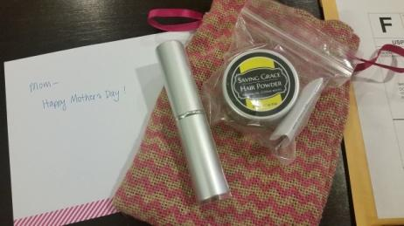

<<< Erica, You are so sweet. I have tears in my eyes....really! Thanks for being so thoughtful! Sincerely, Terry

Traditional merchants and digital first retailers are figuring out the store of the future. For now, it seems everyone can agree on one thing - it’s about building a brand people can’t resist. Ecommerce is transforming buying habits more than ever, thanks to the rise of mobile shopping. There also seems to be a surge of interest in artisanal quality and end products that stand for something meaningful.

The rapid expansion of mobile and online technology, which lets start-ups scale quicker and at a lower cost, combined with a flood of funding has made it easier to stay private longer and achieve higher valuation. Traditional retailers are feeling the crunch created by some of these online start-ups, and huge brands such as Gap, Radio Shack, Macy’s, Barnes & Noble, Abercrombie & Fitch, Aeropostale, and J.C.Penney are closing hundreds of retail locations to adapt to customers rapid change in how they shop today - online. They are also laying off at corporate headquarters in an attempt to be more lean and have the ability to be more decisive, equaling faster response time from the top. Consumers want quality, want transparency, and they want values. The same virtues that mass market retail brands aren’t giving them. The ones that gave rise to online artisanal products.

In a typical brick-and-mortar retail business model, as much as 80% of a product cost is tied up in real estate, distribution, and marketing. Selling directly to consumers online or through product placement in retail outlets (not our own), and avoiding real estate and expensive marketing whenever possible, Saving Grace can invest enormous savings into product quality and lower prices - a kind of competitive double whammy. And as a product that is truly in a class of its own, word of mouth or social media and press coverage might be enough to drive brand awareness all by itself.

The costs of a traditional retail business model is simply unsustainable against ecommerce. While online selling giants such as Amazon provide efficiency, it’s hardly a formula for creating brand loyalty or love among consumers. Saving Grace plans to create a specialized highly personalized vertical online store centered on products that help people and that they actually care about. Never in the history of retail has the opportunity to build a brand been better.

Because we are small, storybranding and sharing our artisanal roots is important. Due to this size, we are able to remain dynamic and respond quickly as new opportunities arise. Although it was not our initial intent, through the desire to get word out about our hair powder without paying advertising fees, we’ve learned allowing others to market the product is effective, although perhaps a short term strategy, as outlined in the marketing mix below.

## Marketing Mix

|  |  |
| --- | --- |
| Advertising  Goal: Capture attention of 50 famous beauty bloggers/reporters  Estimated expense:  $3,000 | Consumers perceive advertised goods as more legitimate. Saving Grace currently promotes new retail salons that carry our products, media hits, reposts popular relevant beauty tips on Facebook and Instagram to align brand with other significant beauty brands and media outlets without spending actual advertising dollars - just $ on product. For example, we are provided hair powders to be featured in Miss America bags in Sept 2015 and will use this opportunity to advertise this placement through our social media pages. |
| Personal Selling  Goal: Gain 3 salon partnerships for shelf space sales  Estimated expense:  $1,000 | Personal interaction allows for feedback and adjustments. Erica ignited excitement about Saving Grace to individuals online who in turn posted and blogged praise about the company and products. On a daily basis, Erica tries to look for every opportunity to share information with others. Erica also ordered business cards with before/after photos so they could also be used as talking points and a marketing tool.  Erica has also attended some “women’s events” hosting a table to market the product, although the actual time vs cost to sponsor the event didn’t necessarily seem to be productive from a bottom line standpoint. |
| Sales Promotion  Estimated expense: % of sales | Run through affiliate online sales at a % off the product as shown in above chart. Buy a powder, get a free mini brush has been successful previously as well. |
| Public Relations  Estimated expense:  $3,500 intern & SEO monthly | Erica currently reaches out to media daily through the online platform “Help A Reporter Out”, and a list of media to target (beauty editors, etc) is currently being written with the intent to contact them and provide a product. SEO Optimization - when people type in “root cover” our product comes up in search results. |

**Operations**

A direct-to-consumer business model is one many manufacturers, including Saving Grace Beauty are discovering can be a powerful engine for consumer research and business growth. By selling directly to the consumer (98% of our sales currently), our profit margin remains the highest, and we are able to boost the value proposition through strategies such as: free, fast shipping, free bonus with purchase, discounted pricing, and customizable services. With this model, we enjoy more direct interaction and influence to the consumer as well.

## Profit chart of powder:

|  |  |  |
| --- | --- | --- |
| Sales channel | Saving Grace Sells for $/unit | Profit per channel |
| www.savinggracehair.com | $14.99 retail | $10.99 profit |
| Wholesale to salons | $9 (40% off retail price) | $5 profit |
| Wholesale to beauty supply wholesaler | $7.50 (50% off retail price) | $3.50 profit |

* Current cost to make a container of Saving Grace Hair Powder is $4. This number is expected to decrease as our purchasing power increases. We are working with contract manufacturer to try and decrease cost to under $2.

## Profit chart of brushes (add-on product):

|  |  |  |  |  |
| --- | --- | --- | --- | --- |
| Brush | Product Source | Saving Grace Cost | Saving Grace Retail | Saving Grace Profit |
| Silver Retractable | TKB Trading | $3.50 | $12.50 | $9 |
| Mini Kabuki | TKB Trading | $1.25 | $9.99 | 8.74 |

Saving Grace Hair Powder is manufactured in our Glen Carbon, IL home office that was renovated that allow us to meet FDA good manufacturing guidelines. The powder product is made here using materials obtained from various manufacturers and then packaged into sifter containers. Master recipes for each color are stored in 2 locations: a hard copy locked in the office safe and an electronic encrypted copy. The brushes are simply resold at a profit.

Currently, the orders flow in from all our ecommerce sales to our shipping clearinghouse site at ShippingEasy.com. (We pay $30 month for this service). From here, Erica purchases postage at a discounted rate through Endicia USPS, and is able to print shipping labels and packing slips. Each order gets a handwritten “thanks” on the invoice and attention is drawn to each customer’s name to seal the personal connection. All orders are shipped within 48 hours. During particularly busy weeks, or times where Erica is unable to keep up with the demand, other team members have previously worked to carry on the business operations, order fulfillment and distribution process.

**Powder Ingredients**

|  |  |  |
| --- | --- | --- |
| Product | Ordered From | Pricing per lb |
| Velvet | TKB | $43.60 |
| Brilliant Gold | TKB | $25 |
| Oriental Beige | TKB | $45 |
| Corn Starch | Sam’s Club | $1.75 |
| Dark Brown Oxide | TKB | $8.98 |
| Brown (M) Oxide | Wholesale Cosmetic Pigments | $22.72 |
| Mica (15 microns) | Wholesale Cosmetic Pigments | $27.44 |
| Black Iron Oxide | TKB | $8.50 |
| Blonde Luster Mica | TKB | $29.50 |
| Satin Black Pearl | Wholesale Cosmetic Pigments | $29.50 |

**Packaging**

|  |  |  |
| --- | --- | --- |
| Container/Sifter/Lid | Making Cosmetics | $1.25 |
| Black Boxes | DIY Cosmetics | $0.36 |
| Labels | MOW Printing, Collinsville IL | $0.20 |
| Plastic Bag Packaging | ClearBags | $0.03 |
| Powder Instruction Slips | MOW Printing, Collinsville IL | $0.03 |

Erica, as the Founder of the business, plans to take over the strategy and business operations of the company. This will allow her to devote her time to new growth opportunities. In order to do so, Saving Grace Beauty will need to acquire resources that can assume those activities, namely being additional team members. The business will hire a part-time employee to help with the logistics of selling: mixing, packaging and shipping. Saving Grace Beauty also has the ability to hire a marketing intern from a local college. An intern would be used for marketing tasks that could increase the brand’s online presence such as content generation and search engine optimization, with the goal of attracting blogger's’ attention that will lead to a larger customer reach. With these new roles in place, Erica will be able to focus her attention on the partnerships needed to acquire new sales locations.

**Management and Organization**

**Erica Harriss**, Founder of Saving Grace Beauty brings considerable experience in marketing and public relations. Erica, an avid learner, started her career in television as a part of selective college internships in the newsroom at KSDK-TV St. Louis, Missouri and WLBT-TV Jackson, Mississippi. She was later hired at KSDK for her ability to effectively communicate, gather information and research, and to lead teams on tight deadlines. Erica also spent time assisting with marketing and human resource efforts for former St. Louis Cardinal baseball player Ozzie Smith at his staffing company. Drawing on her background of a bachelor’s in Public Relations from Southern Illinois University and minor in business, Erica led nationally recognized clients through PR work at GodwinGroup. Most recently, Erica served as the Director of Communications for The National Children’s Cancer Society. Recently, Erica has been busy in a role she jokingly refers to as “keeping the kids alive” to Ryan (10), Julia (8), and Emerson (3). As a stay-at-home mom, Erica’s family is sustainable on her husband Jeff’s salary. This allows Erica flexibility to reinvest any income from Saving Grace back into the company to continue fueling the company’s growth without pressure of providing for a family. As founder, Erica is responsible for: determining and communicating strategic direction and vision, providing proper resources, building culture, making good decisions and overseeing the company's performance.

## Consultants

**Jeff Harriss** is Team Lead, Operations Security Branch at the USDA and recipient of professional accolades, including the esteemed 2014 GISLA Award for his work in computer information security. Jeff advises Saving Grace on business, accounting and computer decisions.

**Tyler Lowe** started his IT career during the dot.COM boom and has worked directly for, or as a consultant to, some of the largest companies in the world including Boeing, Ameren, Anheuser-Busch, Union Pacific Rail Road, Bank of America, SoluXSions, and SSI. He designed our website.

**Jason Schmidt** is a business attorney who specializes in helping his clients protect and exploit their intellectual property. He has focused his practice on helping inventors and small businesses maintain a competitive edge in the marketplace by enforcing intellectual property rights and adding value to their trademarks.

## Advisors

**Patrick McKeehan** is the Director of the Illinois Metro East Small Business Development Center and has been providing counseling to Erica for the last several months on business decisions.

**Ellen Krohne**, Executive Director of the Leadership Council Southwestern Illinois assisted with the Saving Grace business plan, providing her valuable opinions on **focus,** planning and strategic thinking.

**Financial Projections**

|  |  |  |
| --- | --- | --- |
| **START-UP COSTS** |  |  |
| **Saving Grace Beauty Start-Up Cash Projection** | |  |
|  |  |  |
|  |  | **Start-Up** |
|  |  |  |
|  | **Sources of Cash** |  |
|  | Personal Cash | $3,123 |
|  | Cash From Friends & Family |  |
|  | Private Investors |  |
|  | Total Loans |  |
|  | Total Grants |  |
|  | Other |  |
|  | **Total Cash Raised** | **$3,123** |
|  |  |  |
|  | **One-Time Uses** |  |
|  | Advertising (Start-Up Only) |  |
|  | Beginning Product Inventory | 585 |
|  | Construction/ Remodeling |  |
|  | Furntiture/ Decorations | 124 |
|  | Fixtures and Equipment | 823 |
|  | Insurance Fees (One-Time) | 620 |
|  | Licenses and Permit Fees | 546 |
|  | Professional Fees (Contractor, Lawyer, etc.) | 175 |
|  | Rent & Realtors Fee (One-Time) | 0 |
|  | Bar Code Set-Up Costs (One-Time) | 250 |
|  | Unanticipated Costs (10% of Total) |  |
|  | OTHER |  |
|  | **Total One-Time Fees** | **$3,123** |
|  |  |  |
|  | **Total Cash Balance (Working Cap)** | **$0** |

|  |  |
| --- | --- |
| **Saving Grace Beauty LLC** | |
| **Profit and Loss** | |
| **January 1 - November 9, 2015** | |
|  |  |
|  | **Total** |
| **Income** |  |
| **PayPal Income** | 7,019.27 |
| **Refunds-Allowances** | -18.27 |
| **Sales** | 17,214.13 |
| **Total Income** | **$ 24,215.13** |
| **Cost of Goods Sold** |  |
| **Other Costs - COS** | 19.93 |
| **Purchases - COS** | 37.89 |
| **Supplies & Materials - COGS** | 8,321.71 |
| **Total Cost of Goods Sold** | **$ 8,379.53** |
| **Gross Profit** | **$ 15,835.60** |
| **Expenses** |  |
| **Advertising** | 133.21 |
| **Commissions & fees** | 25.00 |
| **Dues & Subscriptions** | 184.96 |
| **Insurance** | 109.00 |
| **Legal & Professional Fees** | 195.00 |
| **Meals and Entertainment** | 168.72 |
| **Office Expenses** | 122.46 |
| **PayPal Fees** | 273.68 |
| **Postage And Delivery** | 11.77 |
| **Promotional** | 85.00 |
| **Repair & Maintenance** | 579.30 |
| **Shipping and delivery expense** | 2,778.87 |
| **Supplies** | 348.40 |
| **Taxes & Licenses** | 211.00 |
| **Tools** | 112.45 |
| **Travel** | 843.93 |
| **Uncategorized Expense** | 174.15 |
| **Total Expenses** | **$ 6,356.90** |
| **Net Operating Income** | **$ 9,478.70** |
| **Net Income** | **$ 9,478.70** |

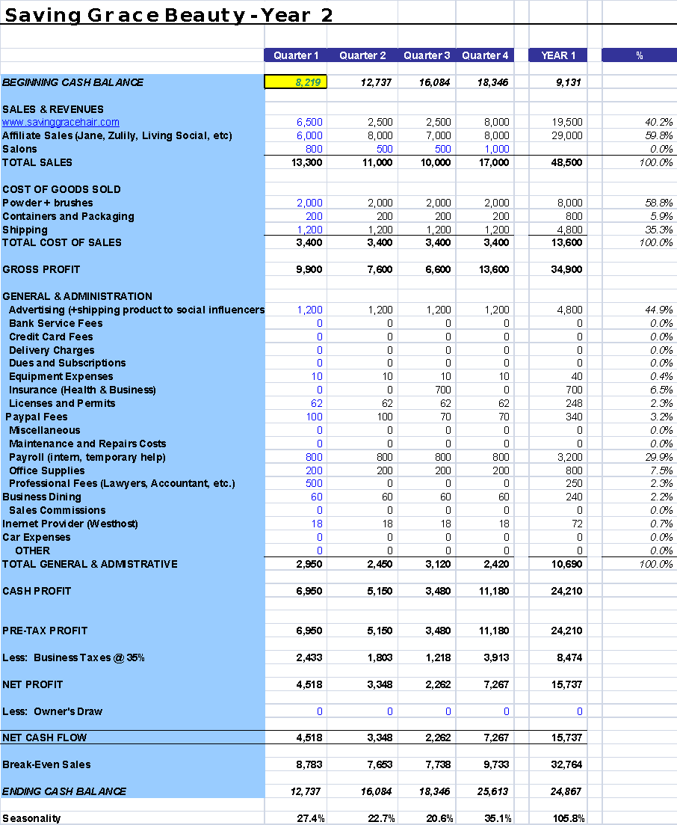

## Notes and Assumptions

Saving Grace Beauty is a sustainable business, but in order to scale-up, the business has outlined the following milestones to achieve $50,000 in sales in 2016.

1. Gain 5 additional salon partnerships for shelf-space sales
2. Increase online sales by 20%
3. Capture the attention of 50 beauty-famous bloggers

To achieve these milestones, Saving Grace Beauty will 1) hire part-time help to do labor intensive work, 2) create a strong online presence for the brand, and 3) devote time to sales partnerships.

* While sales in year 2 increase, costs of these goods actually decrease as the result of entering a relationship with a contract manufacturer. This results in powder pricing going from $4/unit to under $2/unit, and also for brush and container pricing to decrease substantially as well.
* Substantial time in 2016 is scheduled for Erica to build relationships with key media that we hope to see results from either in 2016 or 2017. These financial projections reflect conservative predictions, and a large media hit has the potential to greatly increase sales. For example, with a national media hit, we can expect to meet sales goals for the entire quarter (or more) in a month.

**Appendix**

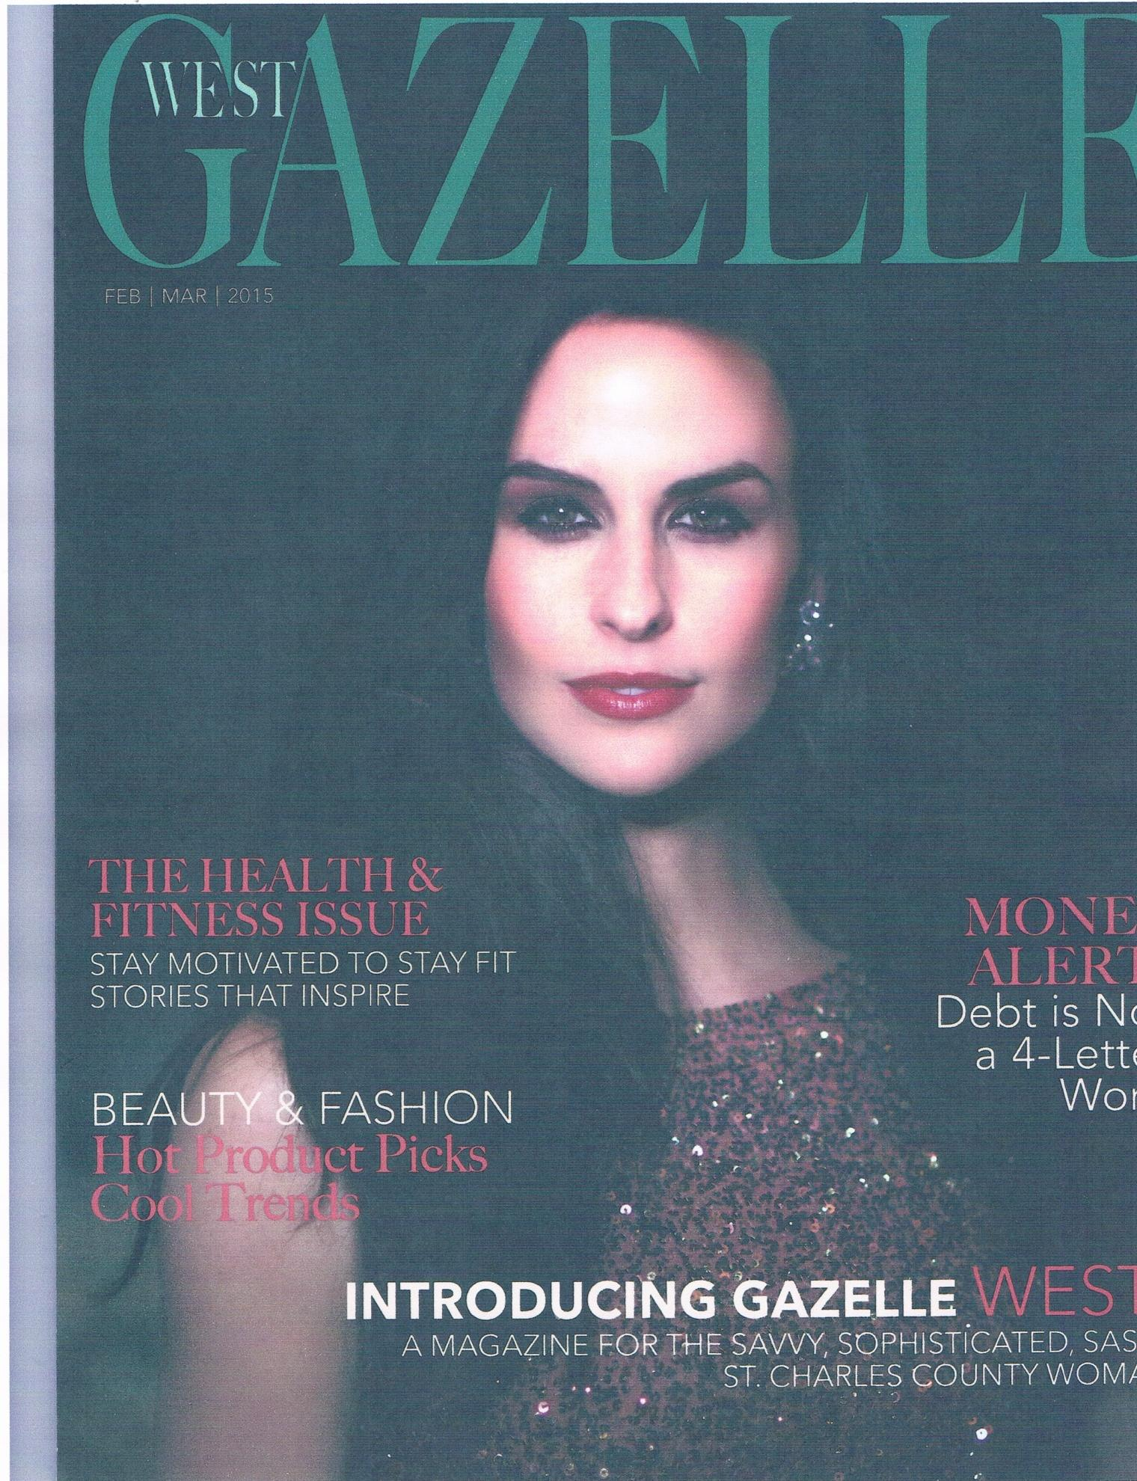

**Gazelle West Cover**

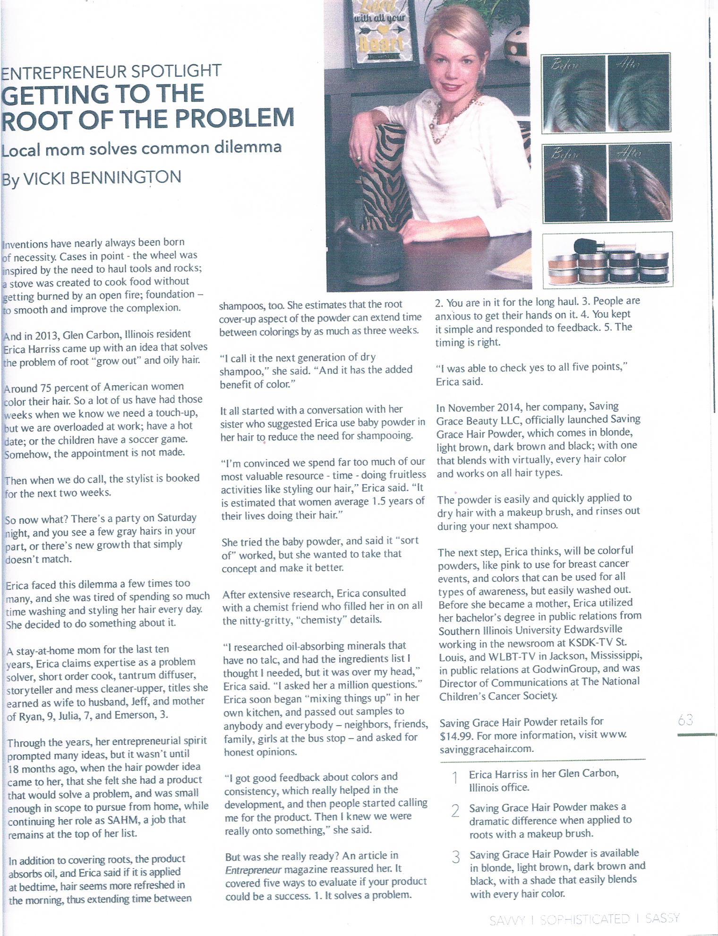

**Gazelle West Article**

## Yahoo Beauty Page 1.PNG

**Yahoo! Beauty Article**

## Yahoo Beauty Page 2.PNG

**Yahoo! Beauty Article Cont.**

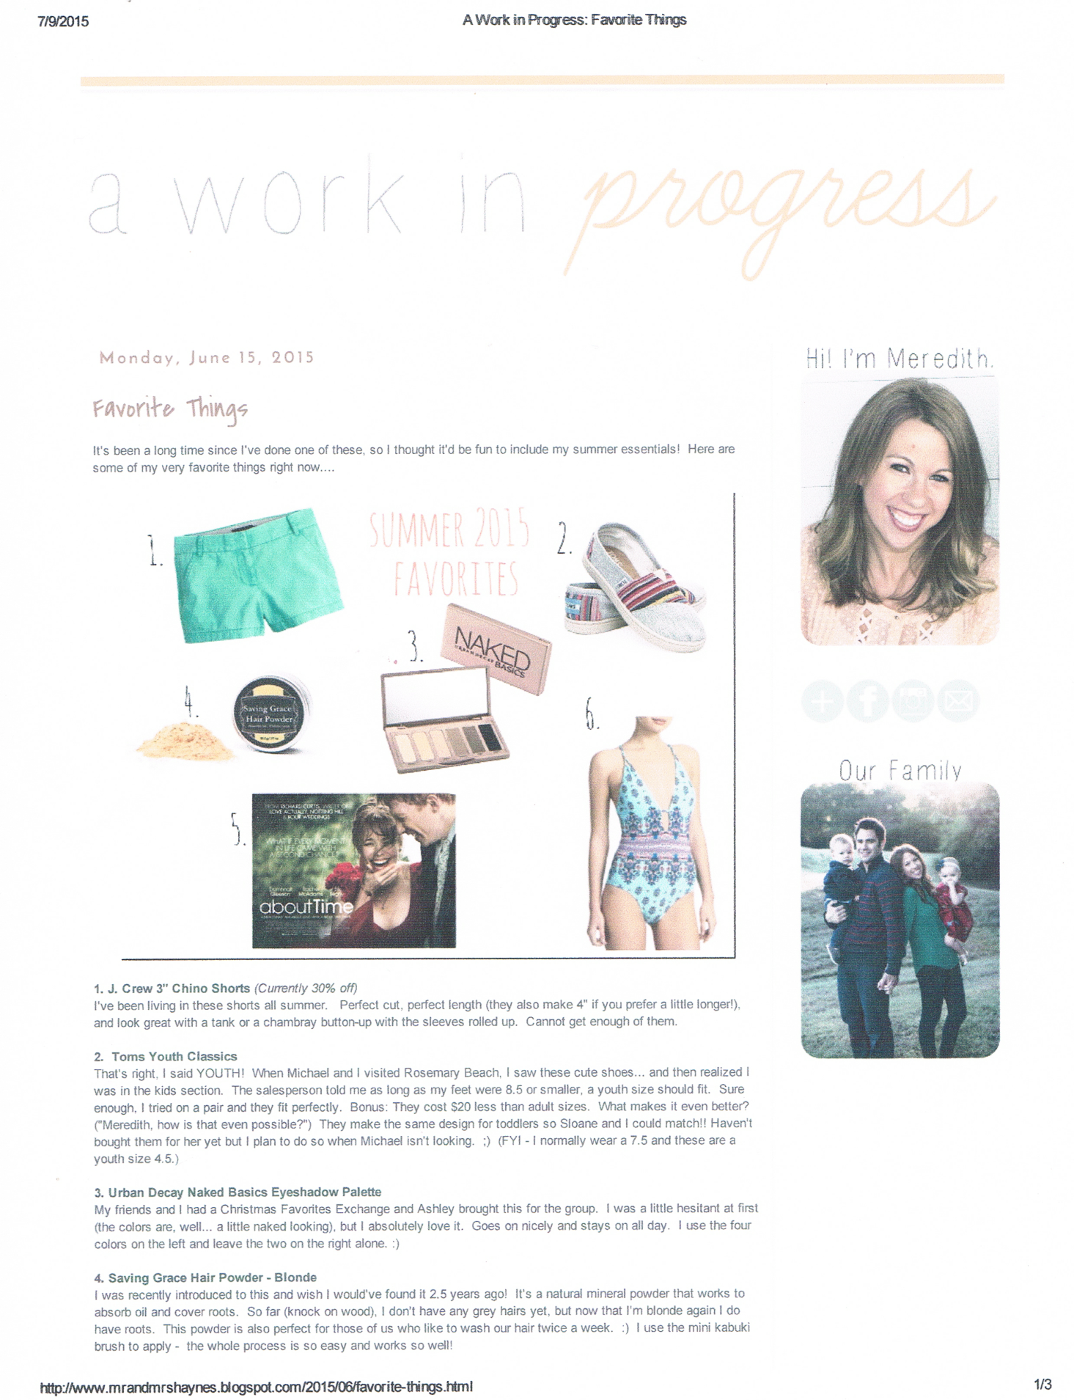

**Blogger Article**

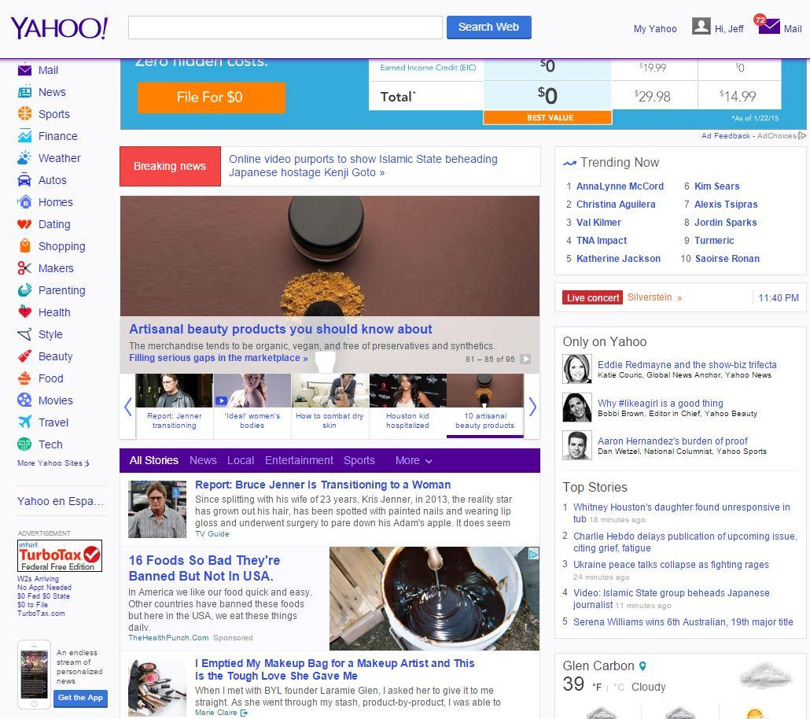

**Yahoo! Front Page**

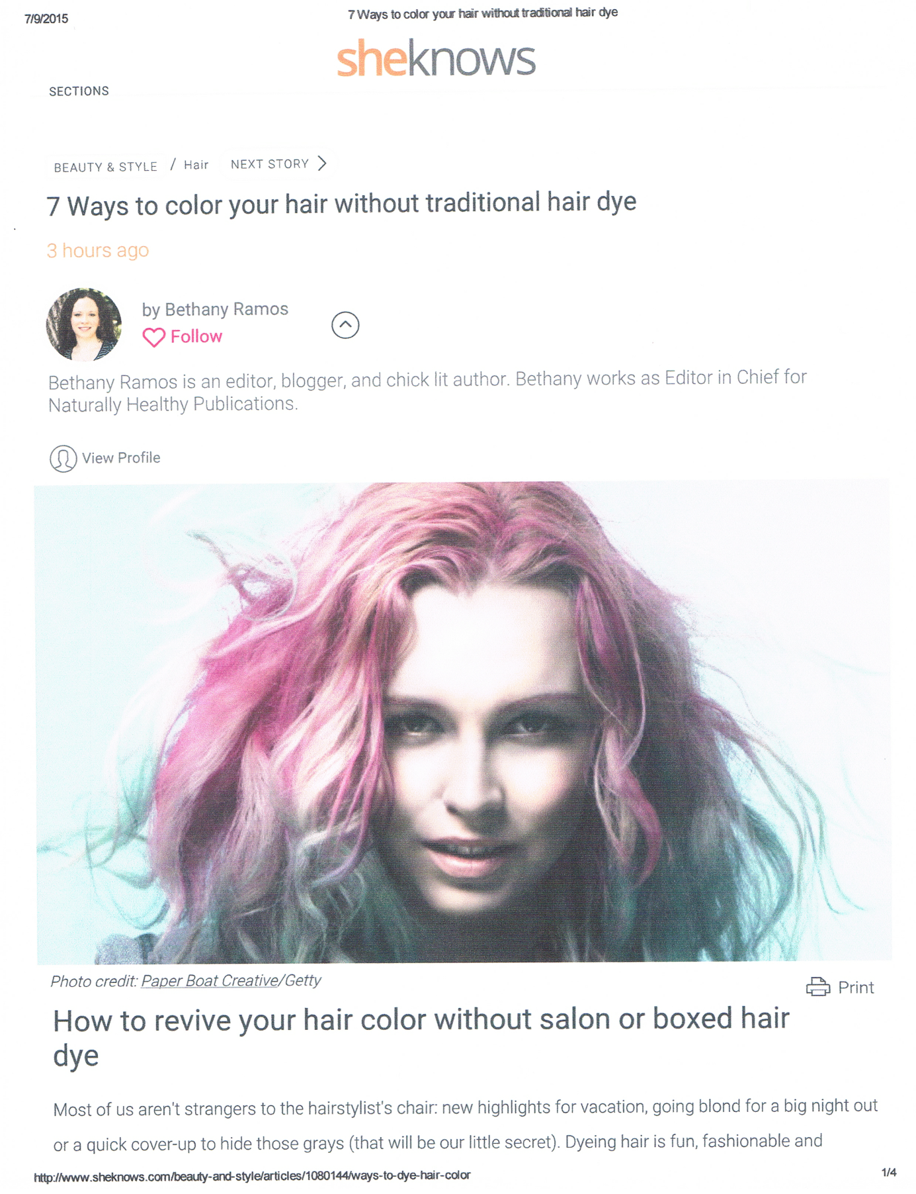

**SheKnows Beauty and Style Artice**

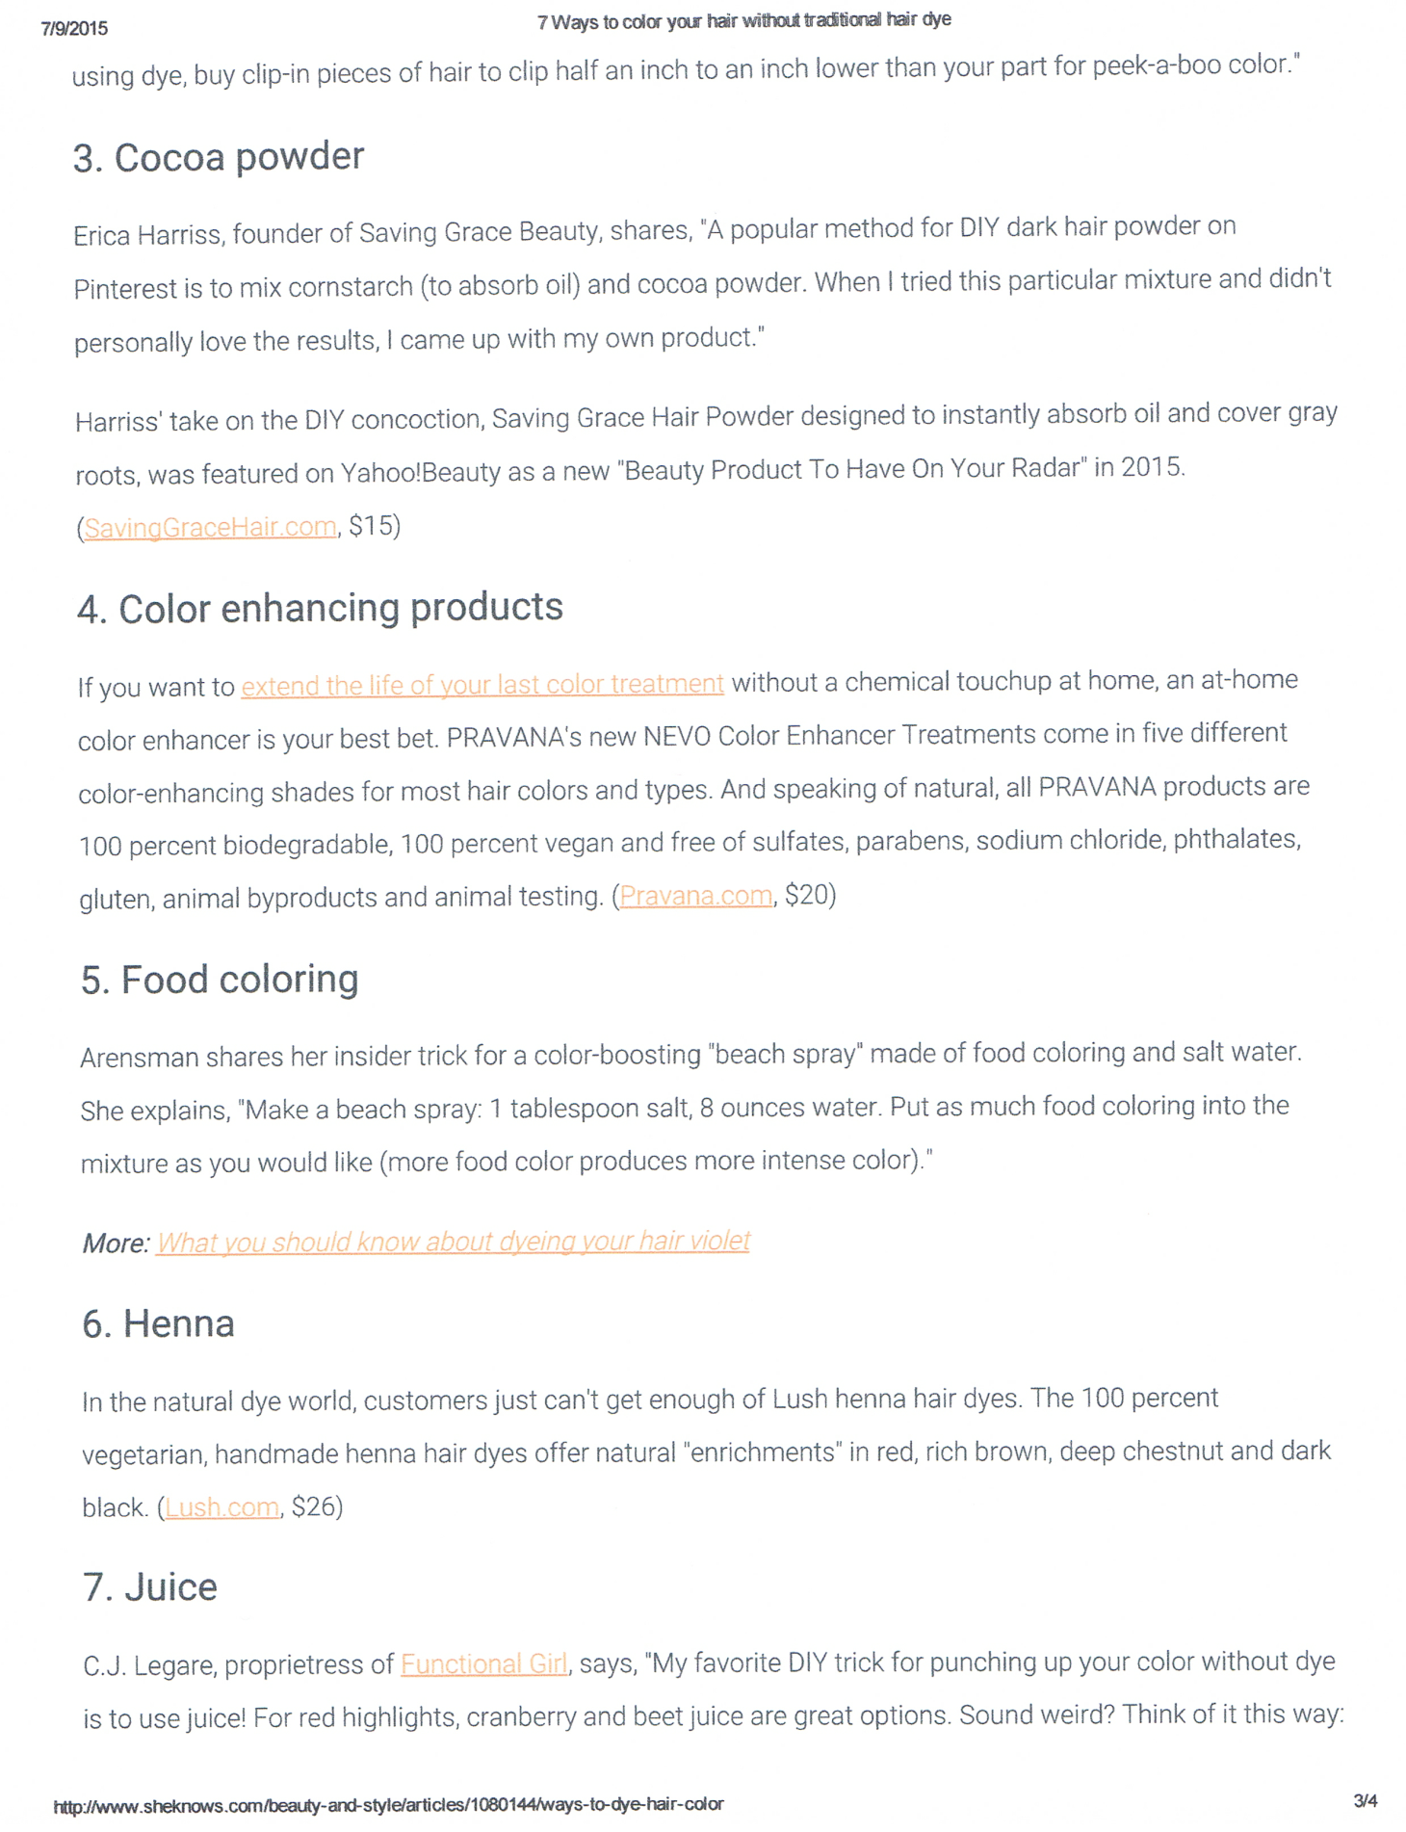

**SheKnows Beauty and Style Article Cont.**

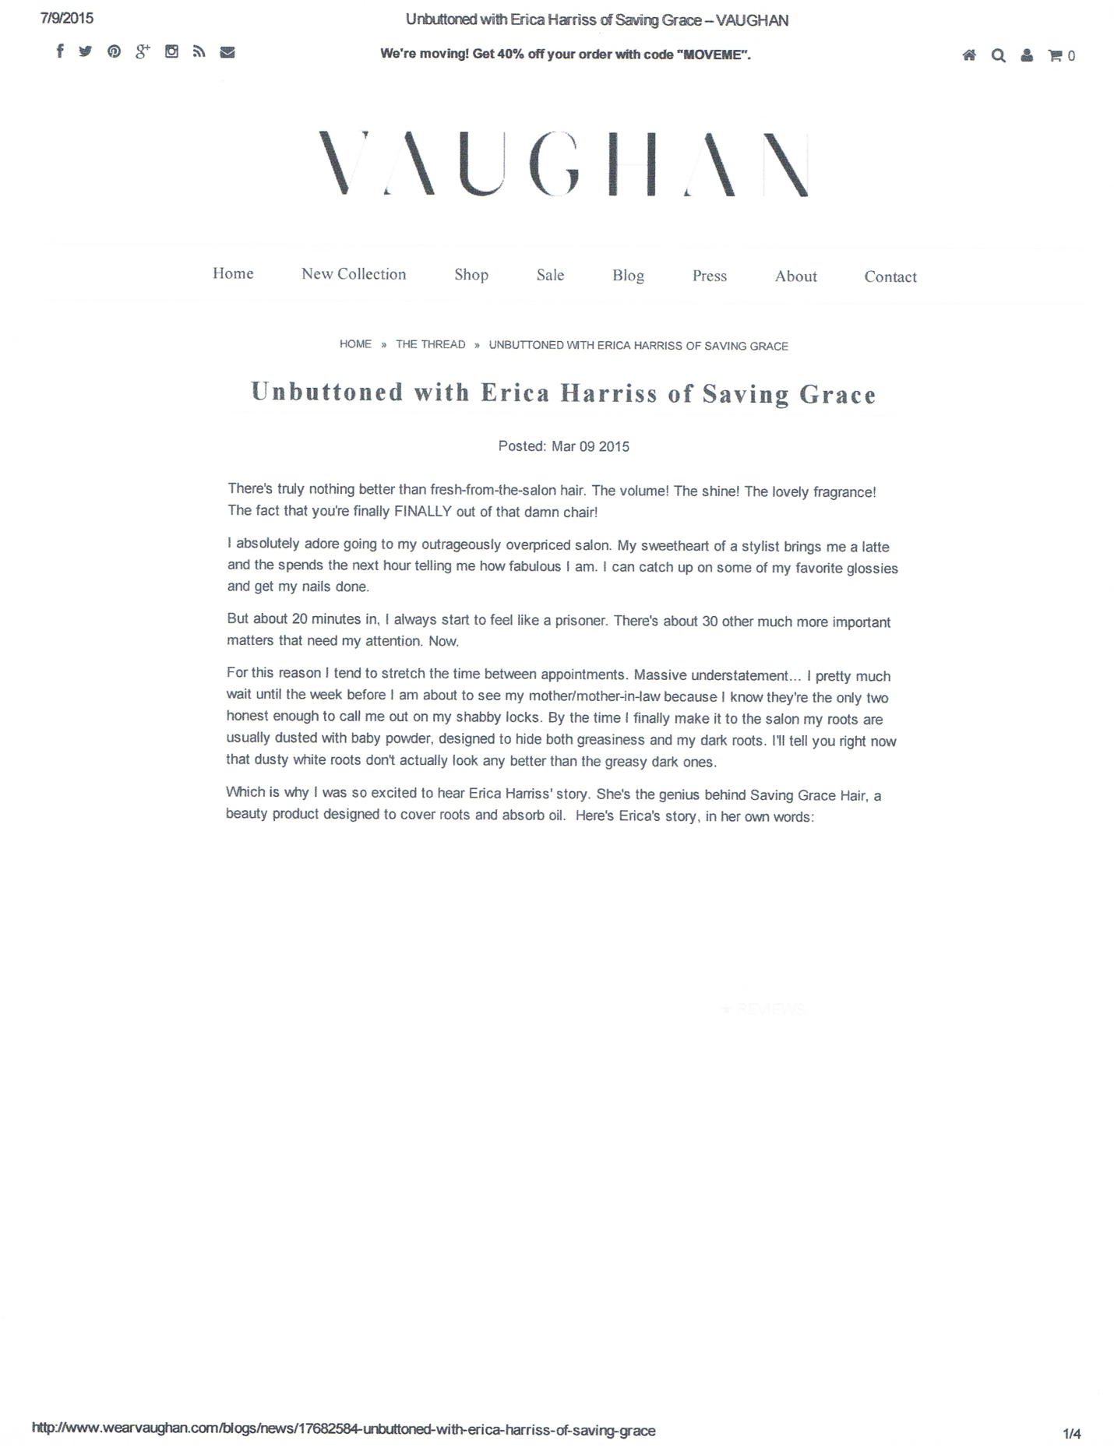

**Vaughan Fashion House Blog**

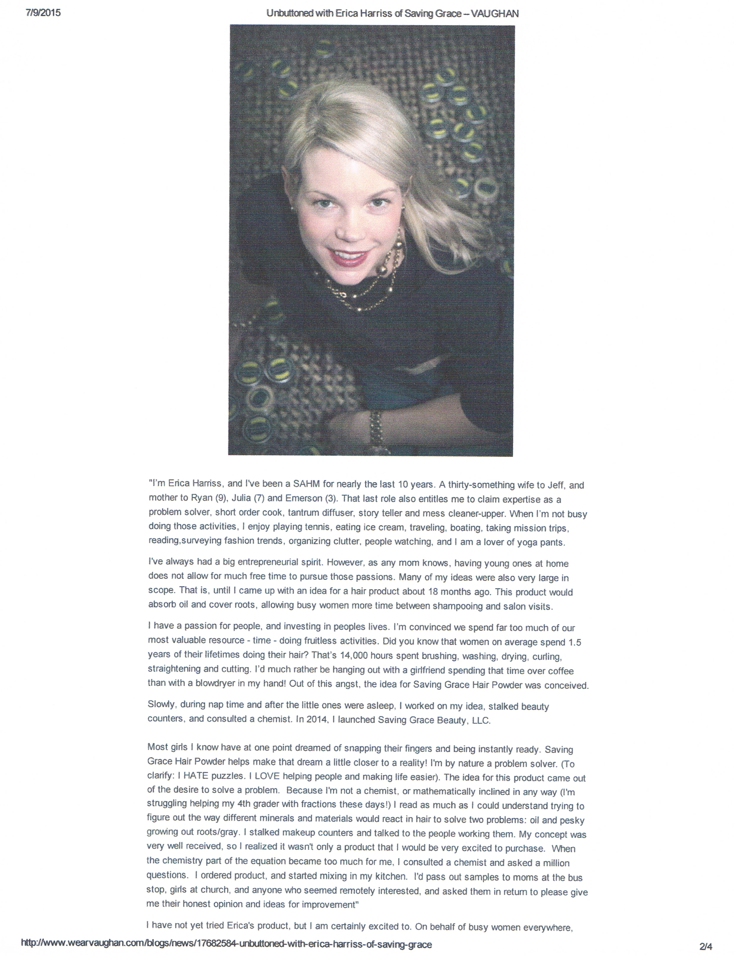

**Vaughan Fashion House Blog Cont.**

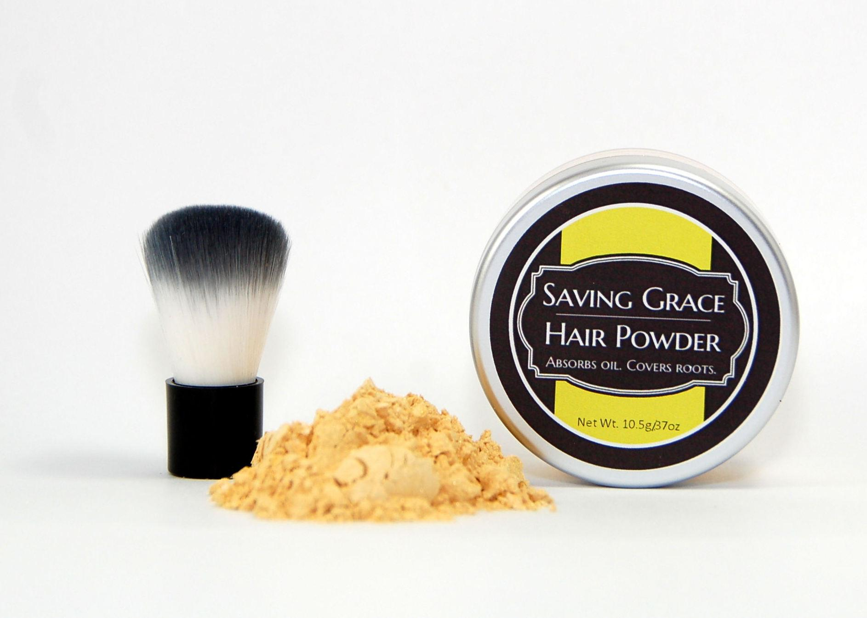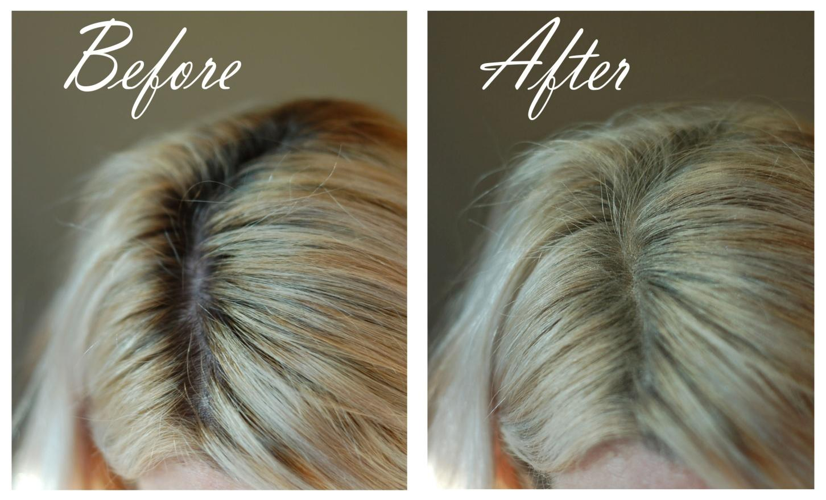

**Before and After Shots**

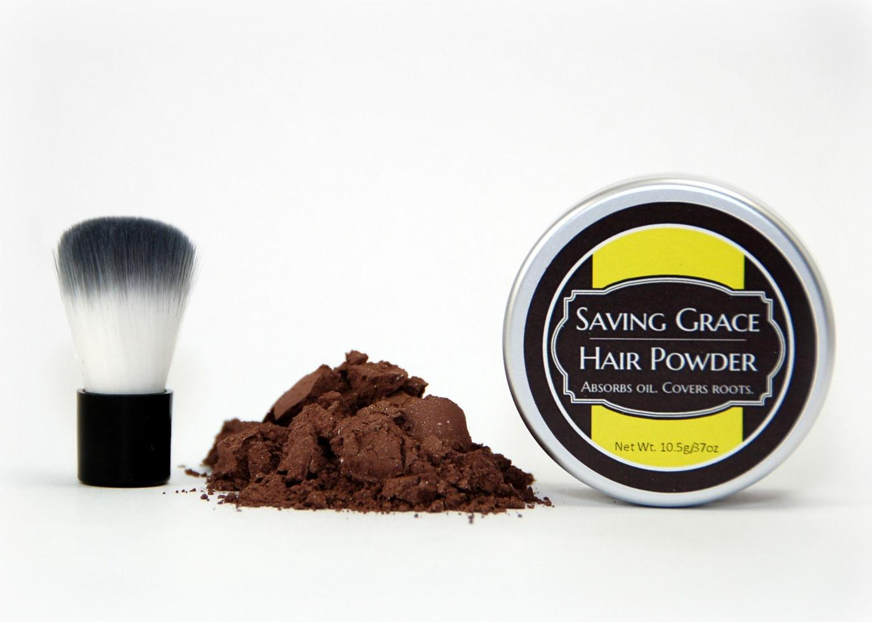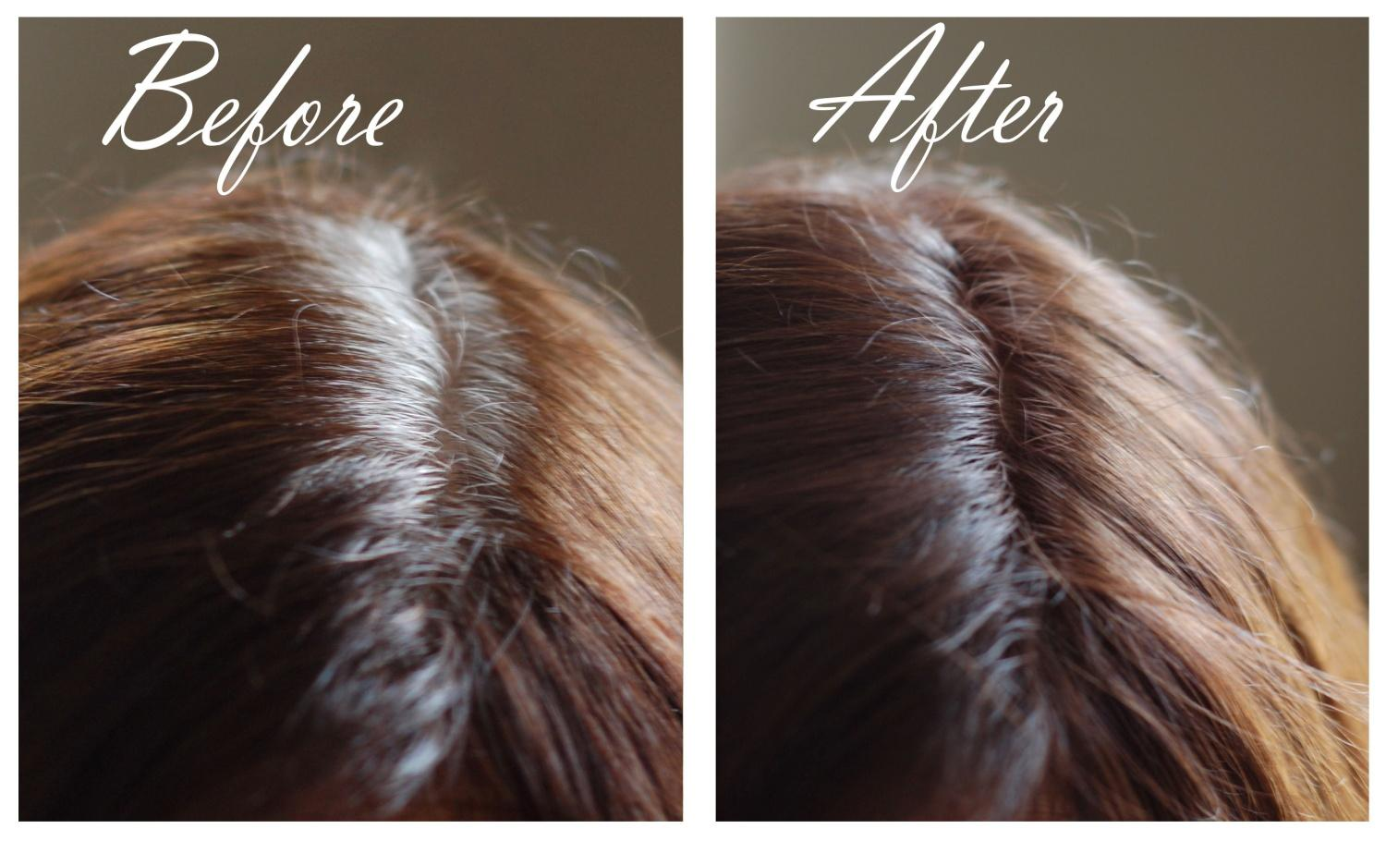

**Before and After Shots Cont.**